WAI4PwDs – Final project results and outcomes
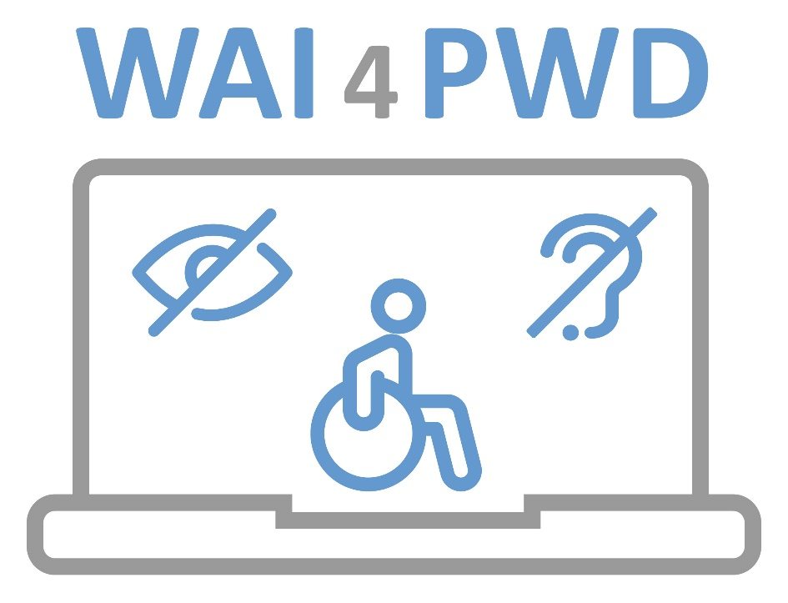

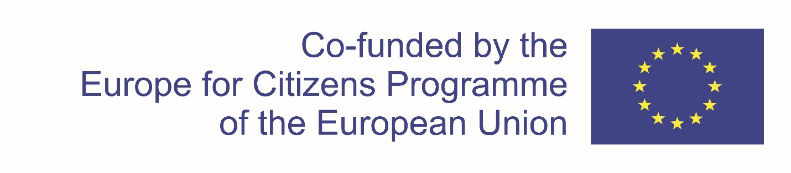

Final project results and outcomes for the Europe for Citizens Project “WAI4PwDs- Web Accessibility and Other Initiatives for Persons with Disabilities in EU in Pandemic and other Crisis Times”

Ref. no. 625053-CITIZ-1-2020-2-RS-CITIZ-NT
The project “WAI4PwDs“ has been approved for a grant worth 136.080,00 EUR from the European Union via the Europe for Citizens Programme, Strand 2. Democratic Engagement and Civic Participation, measure 2.2. Networks of Towns .The project partnership covers 5 European countries (Croatia, Serbia, BiH, Czech Republic and Bulgaria). The lead partner of the project is Regional Development Agency Srem-ltd (Regionalna razvojna agencija Srem, doo), whose vision is to be the link between public, private and civil society in building strategic partnerships through the preparation and implementation of projects that contribute to the improvement of living standards and more balanced regional development in the region of Srem, in the Autonomous Province of Vojvodina and in the Republic Serbia as a whole.The Mission of the RDA Srem is improvement of the quality of standards of living for the population of the district of Srem.
The specific partners on the project are:

o Faculty of Organisation and Informatics (FOI), Croatia
o Centre for education and upbringing „Tomislav Špoljar“ (TŠ), Croatia
o Brčko district of Bosnia and Hercegovina (Bosnia and Hercegovina)
o TMP Association for Employing Poor Eyesight and Visually Impaired Persons (TMP), Bosnia and Hercegovina
o Municipality Prague 9 (Prague 9), Czech Republic
o Association for People with Intellectual Disabilities CHANCE (CHANCE), Bulgaria
o Centre for Economic Empowerment of Roma People (CEUR), Serbia
o Red Cross Sremska Mitrovica (RC SM), Serbia

The project started on March, 1st 2021 and ended on February, 28th 2023.
The project focuses on communities response to rights of persons with disabilities in times of crisis. In the times of forced social distancing, when the whole world is facing challenges such as COVID19 and is turning to ICT tools and contents as a means of dealing with everyday life, PwDs are burdened by the inability to move freely, to fulfill their basic needs and finally to access learning platforms, mobile applications or public content given that only 5% of public websites in EU is fully or partially accessible. When access to all basic services is limited, relying on others but also on online content becomes a precondition of living and if not supported properly by community action, PwDs are left deprived, marginalized to society.The project is organized around two main pillars: first, how a community can take volunteering and solidarity action to cater for PwDs in times of crisis and second, web accessibility initiatives and standards to make digital content more accessible to PwDs. The project is organized as 6 events in SR; HR; BL; CZ; BA that focus on building citizens' understanding on how to manage volunteering actions in times of crisis and importance of digital content accessibility for PwDs in almost all aspects of life (learning, public content, entertainment, professional development and employment, etc.). This will be achieved by organizing workshops, presentations, conferences & site visits, creating new ties & demonstrating good practice. The role EU integration & values play in creating a sense of belonging to the community will also be examined by sharing views and discussions. To sustain results, the partners will develop joint documents and courses that raise citizen capacities to manage local actions. They will also conclude a long-term partnership agreement. Via activities, citizens will gain the knowledge & skills to plan and manage actions in line with democratic principles, enhance understanding of EU and develop transnational links.
The project was organized as six (6) events that were duly carried out within this project:
- Kick off event which took place in Ruma, Serbia over a 3-day period (23/06, 24/06, 25/06/2021).
The aim of the event was to present EU framework and calls for addressing PwDs’ needs in times of crisis, especially to demonstrate how citizen-driven initiatives function in the European context by presenting on how civil society organizations and local public bodies have promoted citizen engagement, solidarity, built a sense of belonging and involved volunteers in their communities;
2. Event 2 which took place in Razlog, Bulgaria, from 08/09/2021 to 10/09/2021. The aim of the event was to start and open the discussion on how volunteers can contribute in crisis times and to get an insight into EU perspective and solidarity. Special focus was put on interaction between digital content, volunteers and persons with disabilities as well as on employment and skills development of persons with disabilities in IT sector.
3. Event 3 which took place in Varaždin, Croatia from 26/04/2022 to 28/04/2022. The aim of the event was to demonstrate how educational institutions and their PwD users and families are coping with covid19 crisis and its implications for learning. ;
4. Event 4 which took place in Prague9, Czech Republic from 14/06/2022 to 16/06/2022. The aim of the event was to show citizens and partners how Prague9 and generally in Czech republic they coped with covid19 in terms of adapting entertaining and tourism content to persons with disabilities.;
5. Event 5 which took place in Sarajevo, Bosnia and Hercegovina from 26/10/2022 to 28/10/2022. The aim of the event was to present methodologies for skills development and employment of persons of disabilities in times of crisis, represented through best social entrepreneurship models in BIH;
6. Final event which took place in Ruma, Serbia from 26/02/2023 to 28/02/2023. The aim of the event was present project achieved results and developed documents, as well as to ensure long-lasting cooperation through signature of Mutual Cooperation Agreement and through thorough discussion of new project ideas and Europe2030 and Sustainable Development Goals.

In our to sustain cooperation and the results of this project, the partnership has concluded a network agreement which details future actions and activities after the project ends.
The following photos have been selected in order give you, the reader, a clear picture of how the activities per event were organized:
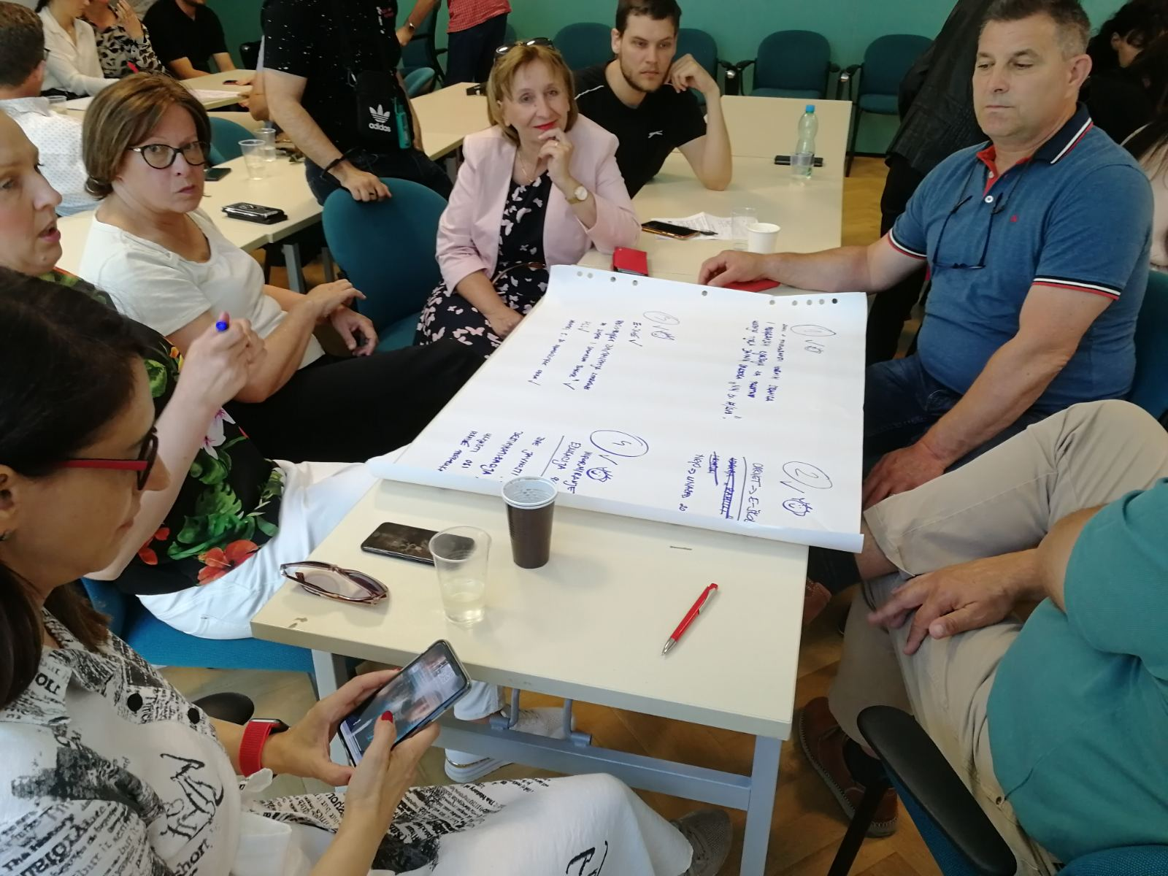
PIC1: Croatian team working on inputs for Web accessibility standards in online education, From the Prague, Czech Republic, conference, June 2022
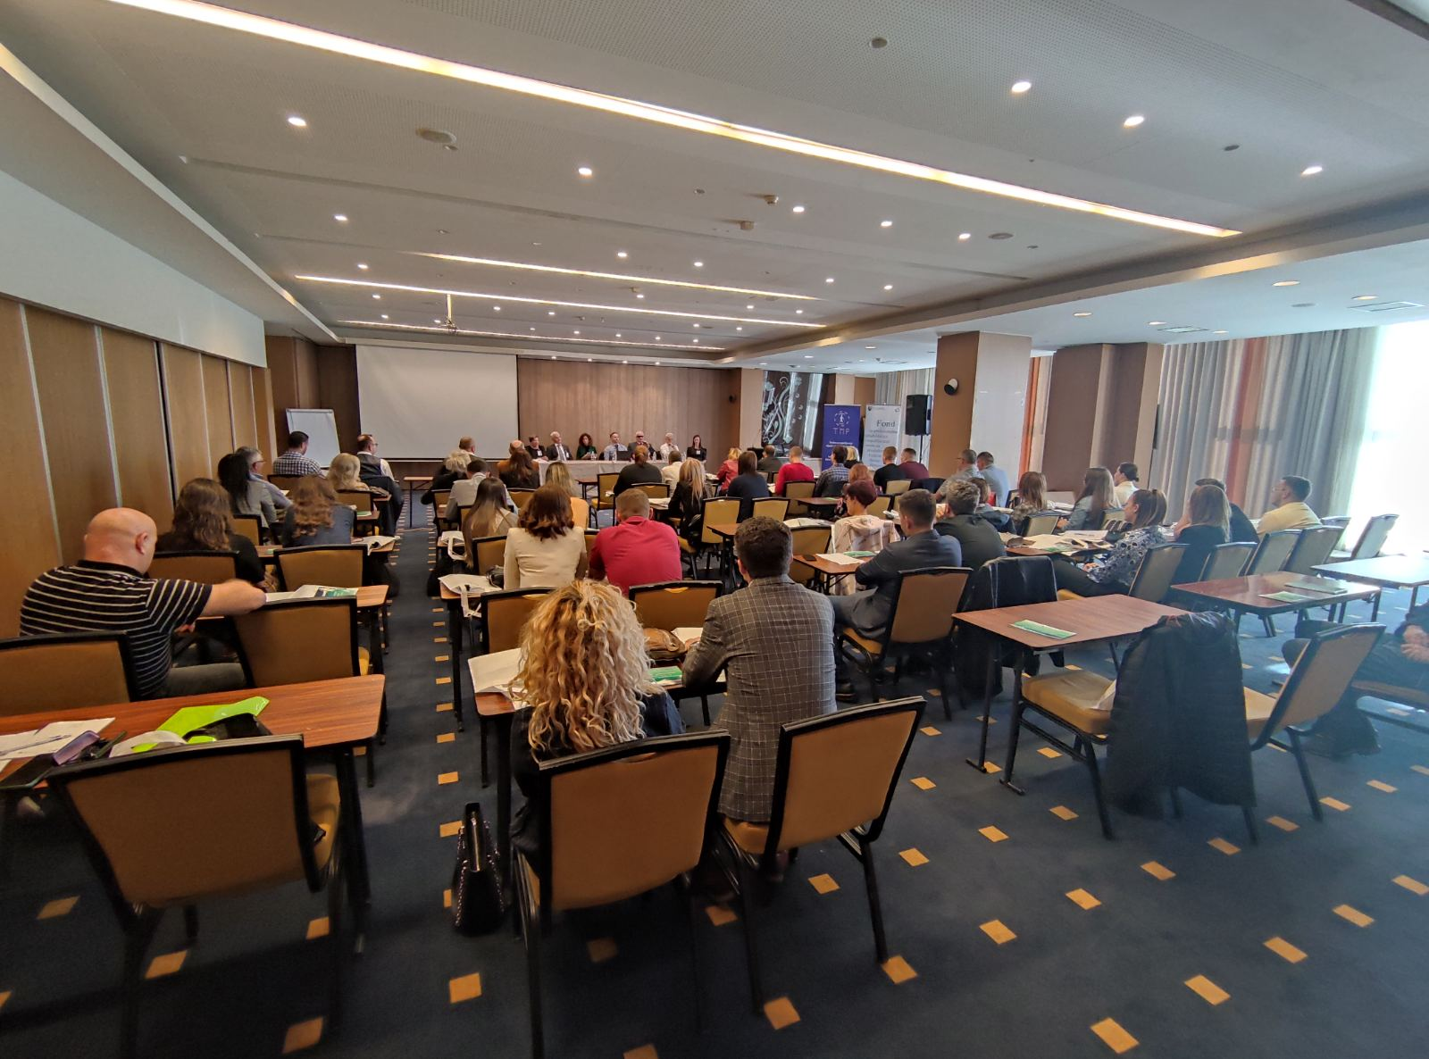

PIC2: Opportunities for PwDs through social entrepreneurship, From the Sarajevo, BiH conference, October 2022

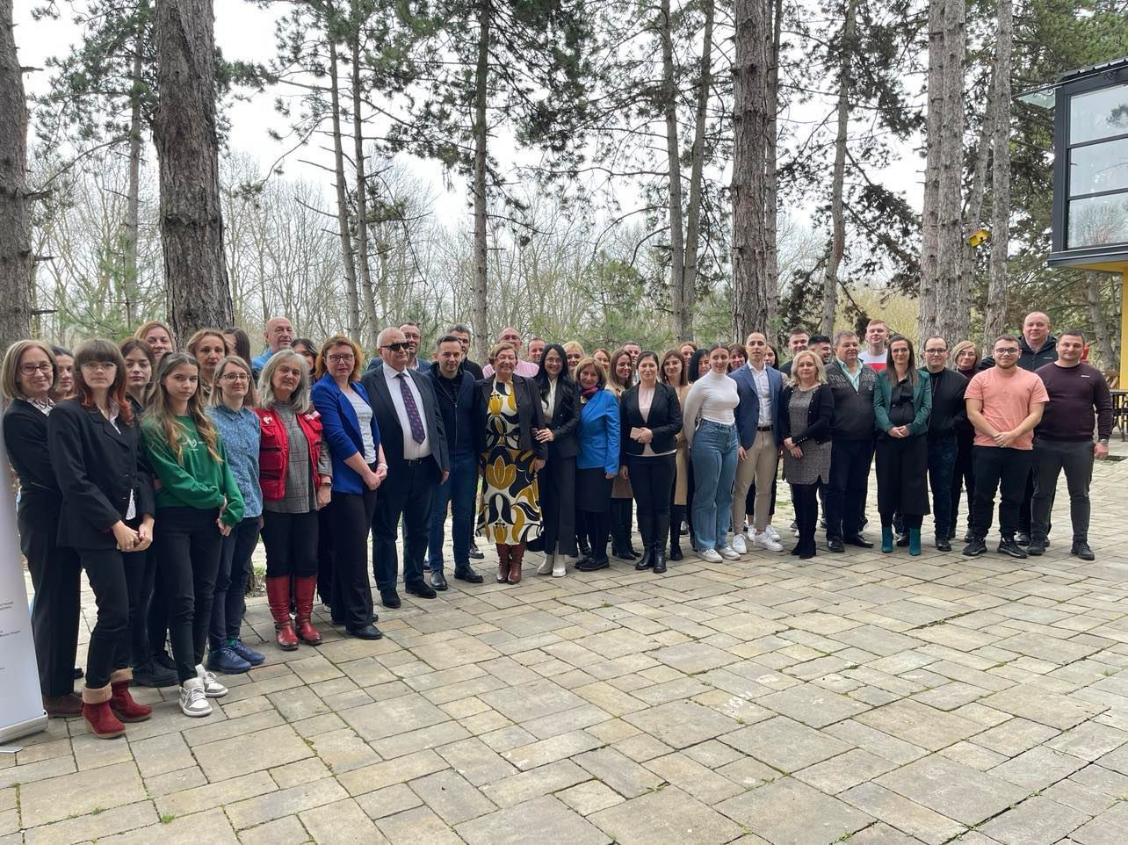

PIC3: After signing Networking agreement, From the Ruma, Serbia final conference, February 2023

For further information on the project and its results, we encourage you to download the OFFICIAL PROJECT SUMMARY.

We also encourage you to download or view the materials that we have created in the project:
- Best practice guide in English
- WAI4PwDs quiz
- WAI4PwDs platform

We hope that you can use our materials for your own projects focusing on rights of persons with disabilities, and we look forward to working together further to enhance action and solidarity in these challenging times.
Disclaimer: The European Commission’s support for the production of this publication does not constitute an endorsement of the contents, which reflect the views only of the authors, and the Commission cannot be held responsible for any use which may be made of the information contained therein.

